CONTACT: Denise Schneider and Ata Younan **FOR IMMEDIATE RELEASE**

312.443.5151 or [Press@GoodmanTheatre.org](mailto:Press@GoodmanTheatre.org) **October 10, 2024**

IMAGES: [Goodman Press Room](https://www.dropbox.com/scl/fo/q5mo5a0es1ujeocmw3agx/h?rlkey=b54smxkp9wz1nwozfx8tatgpj&st=eh9fh6jd&dl=0)

[**PHOTOS AND VIDEO**](https://www.dropbox.com/scl/fo/q5mo5a0es1ujeocmw3agx/h?rlkey=b54smxkp9wz1nwozfx8tatgpj&st=eh9fh6jd&dl=0) **OF NAMIR SMALLWOOD, CHRISTIANA CLARK, CHARLES ANDREW GARDNER, FRED ZIMMERMAN AND MIKE PRZYGODA IN MALKIA STAMPLEY’S CHICAGO PREMIERE PRODUCTION OF EBONI BOOTH’S PULITZER PRIZE-WINNING PLAY, NOW IN PREVIEWS AND OPENING MONDAY, OCTOBER 14**

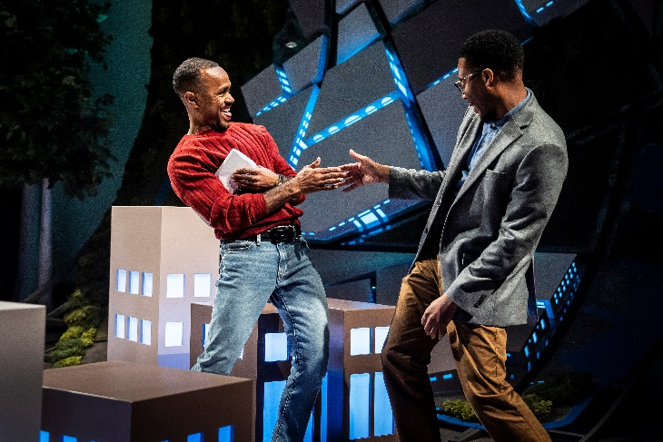

(CHICAGO, IL) Photos and video are now available for the Chicago-premiere production of *Primary Trust* by **Eboni Booth**——helmed by BOLD Artistic Producer **Malkia Stampley**, in her Goodman directing debut. The all-Chicago cast is led by **Namir Smallwood** with **Christiana Clark**, **Charles Andrew Gardner**, **Mike Przygoda** and **Fred Zimmerman**. *Primary Trust* appears October 5 — November 3 (opening night is Monday, October 14 at 7pm. Tickets ($20 - $65; subject to change) are available at GoodmanTheatre.org/Primary or by phone at 312-443-3800. Goodman Theatre is grateful for the support of the Goodman Women’s Board, Bold Theater's Women's Leadership Circle, Conagra Brands Foundation, Mayer Brown and The Elizabeth Morse Charitable Trust.

(L-R) Charles Andrew Gardner and Namir Smallwood

“We have a true ensemble piece with four very different actors who together bring to life this amazing story about loneliness, transition and self-discovery, things that we’re all still dealing with as we continue to transition out of the pandemic” said Stampley. “Eboni Booth is able to brilliantly consider these experiences and remind us that I am you and you are me. A story that says we are all in this together—and we need that reminder now more than ever.”

Winner of the 2024 Pulitzer Prize for Drama, playwright **Eboni Booth** sets *Primary Trust* in “Cranberry, New York—a medium-sized suburb of Rochester (in) a time before smart phones.” 38-year-old Kenneth is a longtime bookstore worker who is perfectly content with his after-work routine: a mai tai—or two—at the local tiki bar. But when his employer decides to close the store, Kenneth must also turn the page and choose a new direction—including some daring steps into a world he has evaded.

**FULL COMPANY OF *Primary Trust*** (in alphabetical order)

In the Owen Theatre

By Eboni Booth

Directed by Malkia Stampley

**Christiana Clark**…Corrina/Wally’s Waiter/Bank Customers

**Charles Andrew Gardner**…Bert

**Mike Przygoda**…Onstage Musician

**Namir Smallwood**…Kenneth

**Fred Zimmerman**…Clay/Sam/Le Pousselet Bartender

Understudies for this production include **Daniel Ajak**, **Victoria Angelica Cruz**, **Sam Hyson**, **Christopher Meister** and **Keith Surney**.

**Creative Team**

Associate Director…**Ericka Ratcliff**

Set Designer…**Lex Liang**

Costume Designer…**Yvonne Miranda**

Lighting Designer…**Heather Gilbert**

Sound Designer and Composer….**Brandon Reed**

Composer…**Mike Przygoda**

Movement Consultant…**Raquel Torre**

Voice and Dialect Coach…**Eva Breneman**

Casting is by **Lauren Port**, CSA. **Lena Romano** is the Dramaturg. **Pat Fries** is the Production Stage Manager.

**ABOUT GOODMAN THEATRE**

Chicago’s theater since 1925, **Goodman Theatre** is a not-for-profit arts and community organization in the heart of the Loop, distinguished by the excellence and scope of its artistic programming and community engagement. Led by Artistic Director **Susan V. Booth** and Executive Director **John Collins**, the theater’s artistic priorities include new play development (more than 150 world or American premieres), large scale musical theater works and reimagined classics. Artists and productions have earner two Pulitzer Prizes, 22 Tony Awards and nearly 200 Joseph Jefferson Awards, among other accolades.

The Goodman is the first theater in the world to produce all 10 plays in August Wilson’s “American Century Cycle.” Its longtime annual holiday tradition *A Christmas Carol*, now in its fifth decade, has created a new generation of theatergoers in Chicago. The Goodman also frequently serves as a production and program partner with national and international companies and Chicago’s Off-Loop theaters.

Using the tools of theatrical practice, the Goodman’s Education and Engagement programs aim to develop generations of citizens who understand and empathize with cultures and stories of diverse voices. The Goodman’s Alice Rapoport Center for Education and Engagement is the home of these programs, which are offered for Chicago youth—85% of whom come from underserved communities—schools and life-long learners.

Goodman Theatre was built on the traditional homelands of the Council of the Three Fires: the Ojibwe, Odawa and Potawatomi Nations. We recognize that many other Nations consider the area we now call Chicago as their traditional homeland—including the Myaamia, Ho-Chunk, Menominee, Sac and Fox, Peoria, Kaskaskia, Wea, Kickapoo and Mascouten—and remains home to many Native peoples today. While we believe that our city’s vast diversity should be reflected on the stages of its largest theater, we acknowledge that our efforts have largely overlooked the voices of our Native peoples. This omission has added to the isolation, erasure and harm that Indigenous communities have faced for hundreds of years. We have begun a more deliberate journey towards celebrating Native American stories and welcoming Indigenous communities.

Goodman Theatre was founded by William O. Goodman and his family in honor of their son Kenneth, an important figure in Chicago’s cultural renaissance in the early 1900s. The Goodman family’s legacy lives on through the continued work and dedication of Kenneth’s family, including Albert Ivar Goodman, who with his late mother, Edith-Marie Appleton, contributed the necessary funds for the creation on the new Goodman center in 2000.

**Julie Danis** is Chair of Goodman Theatre’s Board of Trustees, **Lorrayne Weiss** is Women’s Board President and **Kelli Garcia** is President of the Scenemakers Board for young professionals.

—30—