CONTACT: Denise Schneider and Ata Younan FOR IMMEDIATE RELEASE
312.443.5151 or Press@GoodmanTheatre.org January 21, 2025
IMAGES: Goodman Theatre Press Room

FAT HAM OPENS TONIGHT – WITH HIGH DEMAND FOR TICKETS EXTENDING THE CHICAGO PREMIERE THROUGH MARCH 2
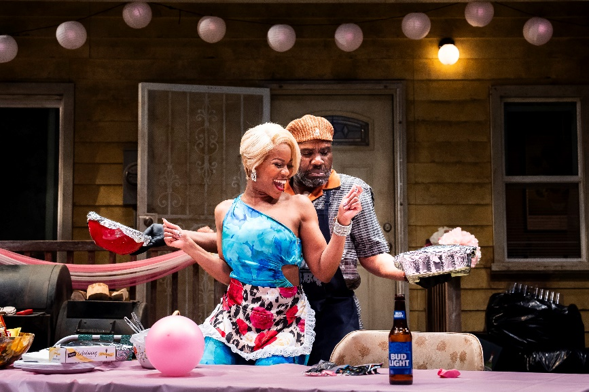
(Chicago, IL) It’s opening night for Tyrone Phillips’ Chicago premiere-production of James Ijames’s Pulitzer Prize-winning, five-time Tony Award-nominated play Fat Ham—which extends by popular demand with eight additional performances. Co-produced with Chicago’s famed Definition Theatre—of which Phillips is Founding Artistic Director and Ijames is a company member—Fat Ham tells the story of Juicy, a Black, queer young man who is confronted by the ghost of his father during a family barbeque. Seeking revenge for his murder, his father puts a screeching halt to Juicy’s quest for joy and liberation. Ijames’s reinvention of Shakespeare’s masterpiece features an all-Chicago cast: Trumane Alston (Juicy), Sheldon Brown, E. Faye Butler, Ronald L. Conner, Victor Musoni, Ireon Roach and Anji White. Fat Ham opens tonight and runs through March 2. Tickets ($25 - $85; subject to change) are available at GoodmanTheatre.org/Ham or by phone at 312.443.3800. Goodman Theatre is grateful for the support of ITW (Corporate Sponsor Partner) and the Elizabeth Morse Charitable Trust (Lead Sponsor of IDEAA Programming).
EXTENSION WEEK SCHEDULE

-Tuesday, February 25 at 7:30pm
-Wednesday, February 26 at 7:30pm
-Thursday, February 27 at 2pm and 7:30pm
-Friday, February 28 at 7:30pm
-Saturday, March 1 at 2pm and 7:30pm
-Sunday, March 2 at 2pm

Special events for the production include: Drinks and Discussion: Conversation with Definition Theatre (January 24) featuring a panel of the talented Black creatives behind the Chicago-premiere production exploring the unique experiences and perspectives of Black queer artists; Black Affinity Night (February 7) celebrates the richness of Black culture and community at a special pre-show reception and conversation, followed by the evening performance.
Full Company of Fat Ham (in alphabetical order)
By James Ijames
Directed by Tyrone Phillips

Trumane Alston…Juicy
Sheldon Brown…Larry
E. Faye Butler…Rabby
Ronald L. Conner…Rev/Pap
Victor Musoni…Tio
Ireon Roach…Opal
Anji White…Tedra
Understudies for this production include Blake Hamilton Currie, Marquise De’Jahn, TayLar, Joseph Primes and Jazzy Rush.
Creative Team

Set Designer…..Arnel Sancianco
Costume Designer ……Jos N. Banks
Lighting Designer…..Jason Lynch
Sound Designer….. Willow James
Illusion Consultant…Benjamin Barnes
Fight and Intimacy…Gaby Labotka
Casting is by Lauren Port, CSA. Jared Bellot is the Dramaturg. Patrick Fries is the Production Stage Manager.

ENHANCED AND ACCESSIBLE PERFORMANCES AT GOODMAN THEATRE
ASL-Interpreted Performance: Friday, January 31 at 7:30pm – Professional ASL interpreter signs the action/text as played.
Touch Tour* and Audio-Described Performance: Saturday, February 1, 12:30pm Touch Tour; 2pm performance – The action/text is audibly enhanced for patrons via headset.
Spanish-Subtitled Performance: Saturday, February 1 at 7:30pm – An LED sign presents Spanish-translated dialogue in sync with the performance.
Open-Captioned Performance: Sunday, February 2 at 2pm – An LED sign presents dialogue in sync with the performance.
Visit Goodman theatre.org/Access for more information about Goodman Theatre’s accessibility efforts.
ABOUT DEFINITION THEATRE
Definition Theatre has been a vibrant force for over a decade, celebrating stories created with, inspired by, and intended for people and communities of color. Through the act of making, Definition expands perspectives, stewards resources, and bridges the possibilities found at the intersection of art, innovation, and education. Known for bold and impactful productions, we’ve brought to life plays by Oscar-winner Tarell Alvin McCraney, Pulitzer Prize-winners James Ijames and Jackie Sibblies Drury, and Tony Award-winner Branden Jacobs-Jenkins. We strive to promote equity, foster empathy, and enhance the quality of life for our community members by offering opportunities for creative, entrepreneurial, and cultural expression. Our work emphasizes collaboration in theater-making and raises awareness of career paths in the arts. In 2024, Definition leased and equipped a storefront space in Hyde Park, enabling us to engage artists and expand programs as we prepare for our permanent home in Woodlawn on the southside of Chicago. This new theater, community center, and business incubator will amplify and preserve BIPOC voices, promote social justice, and empower the next generation of artists, entrepreneurs, and changemakers to drive positive progress through the transformative power of the arts. Tyrone Phillips is the Artistic Director, Neel McNeill is the Executive Director, Willow James is the Civic Engagement Director.
ABOUT GOODMAN THEATRE

Chicago’s theater since 1925, Goodman Theatre is a not-for-profit arts and community organization in the heart of the Loop, distinguished by the excellence and scope of its artistic programming and community engagement. Led by Artistic Director Susan V. Booth and Executive Director John Collins, the theater’s artistic priorities include new play development (more than 150 world or American premieres), large scale musical theater works and reimagined classics. Artists and productions have earned two Pulitzer Prizes, 22 Tony Awards and more than 160 Jeff Awards, among other accolades.

The Goodman is the first theater in the world to produce all 10 plays in August Wilson’s “American Century Cycle.” Its longtime annual holiday tradition A Christmas Carol, now in its fifth decade, has created a new generation of theatergoers in Chicago. The Goodman also frequently serves as a production and program partner with national and international companies and Chicago’s Off-Loop theaters.

Using the tools of theatrical practice, the Goodman’s Education and Engagement programs aim to develop generations of citizens who understand and empathize with cultures and stories of diverse voices. The Goodman’s Alice Rapoport Center for Education and Engagement is the home of these programs, which are offered for Chicago youth—85% of whom come from underserved communities—schools and life-long learners.

Goodman Theatre was built on the traditional homelands of the Council of the Three Fires: the Ojibwe, Odawa and Potawatomi Nations. We recognize that many other Nations consider the area we now call Chicago as their traditional homeland—including the Myaamia, Ho-Chunk, Menominee, Sac and Fox, Peoria, Kaskaskia, Wea, Kickapoo and Mascouten—and remains home to many Native peoples today. While we believe that our city’s vast diversity should be reflected on the stages of its largest theater, we acknowledge that our efforts have largely overlooked the voices of our Native peoples. This omission has added to the isolation, erasure and harm that Indigenous communities have faced for hundreds of years. We have begun a more deliberate journey towards celebrating Native American stories and welcoming Indigenous communities.

Goodman Theatre was founded by William O. Goodman and his family in honor of their son Kenneth, an important figure in Chicago’s cultural renaissance in the early 1900s. The Goodman family’s legacy lives on through the continued work and dedication of Kenneth’s family, including Albert Ivar Goodman, who with his late mother, Edith-Marie Appleton, contributed the necessary funds for the creation on the new Goodman center in 2000.
Julie Danis is Chair of Goodman Theatre’s Board of Trustees, Lorrayne Weiss is Women’s Board President and Kelli Garcia is President of the Scenemakers Board for young professionals.

—30—

