CONTACT: Denise Schneider and Ata Younan FOR IMMEDIATE RELEASE
312.443.5151 or Press@GoodmanTheatre.org February 6, 2025

IMAGES: Goodman Theatre Press Room

HIGH DEMAND FOR TICKETS PROMPTS EXTENSIONS OF TWO GOODMAN PRODUCTIONS

***FAT HAM EXTENDS A SECOND TIME (THROUGH MARCH 9) AND SUSAN V. BOOTH’S MAJOR REVIVAL OF
BETRAYAL, STARRING IAN BARFORD, HELEN HUNT AND ROBERT SEAN LEONARD, EXTENDS THROUGH MARCH 23***

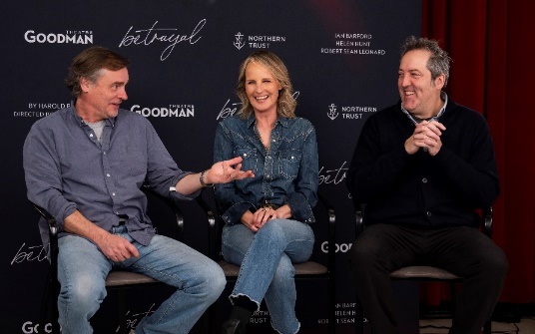
(Chicago, IL) The new year is off to a strong start on stage as Goodman Theatre announces additional performances for both of its current productions: Fat Ham in the 350-seat Owen Theatre—marking the second extension for Tyrone Phillips’ Chicago-premiere production of James Ijames’ Pulitzer Prize-winning play—and Susan V. Booth’s major revival of Betrayal in the 856-seat Albert Theatre. Dates and times for the extension week performances appear below. Betrayal, which begins performances this weekend, features Tony Award nominee and Outer Critics Circle Award winner Ian Barford as Robert, Oscar, Emmy and Golden Globe Award winner Helen Hunt as Emma and Tony Award winner Robert Sean Leonard as Jerry in Harold Pinter’s masterwork. Betrayal appears February 8 – March 23 (opening night is February 17). Tickets ($40 - $175; subject to change) are available at GoodmanTheatre.org/Betrayal or by phone at 312.443.3800. The Goodman is grateful for the support of Northern Trust (Lead Corporate Sponsor), Katten Muchin Rosenmann LLP and PAXXUS, Inc. (Corporate Sponsor Partners).
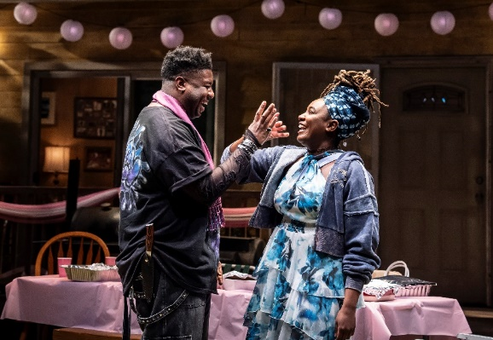
Fat Ham, the “heartwarming, tension-filled and laugh-out-loud funny” (Daily Herald) reimagination of Shakespeare’s Hamlet directed by Tyrone Phillips adds five performances to its Chicago run with a second extension. Co-produced with Chicago’s famed Definition Theatre—of which Phillips is Founding Artistic Director and playwright James Ijames is a company member—Fat Ham tells the story of Juicy, a Black, queer young man who is confronted by the ghost of his father during a family barbeque. Seeking revenge for his murder, his father puts a screeching halt to Juicy’s quest for joy and liberation. Ijames’s reinvention of Shakespeare’s masterpiece features an all-Chicago cast: Trumane Alston (Juicy), Sheldon Brown, E. Faye Butler, Ronald L. Conner, Victor Musoni, Ireon Roach and Anji White. Fat Ham appears through March 9. Tickets ($35 - $85; subject to change) are available at GoodmanTheatre.org/Ham or by phone at 312.443.3800. Goodman Theatre is grateful for the support of ITW (Corporate Sponsor Partner), the Elizabeth Morse Charitable Trust (Lead Sponsor of IDEAA Programming) and the National Endowment for the Arts (Production Support).
FAT HAM EXTENSION WEEK SCHEDULE

-Thursday, March 6 at 7:30pm
-Friday, March 7 at 7:30pm
-Saturday, March 8 at 2pm
-Saturday, March 8 at 7:30pm
-Sunday, March 9 at 2pm

BETRAYAL EXTENSION WEEK SCHEDULE
-Tuesday, March 18 at 7:30pm
-Wednesday, March 19 at 2pm
-Wednesday, March 19 at 7:30pm
-Thursday, March 20 at 7:30pm
-Saturday, March 22 at 2pm and 7:30pm*
-Sunday, March 23 at 2pm and 7:30pm

*At these two performances, the role of Emma will be played by Cheyenne Casebier.

Full Company of Betrayal (in alphabetical order)
By Harold Pinter
Directed by Susan V. Booth

Ian Barford…Robert
Nico Grelli…Waiter
Helen Hunt…Emma
Robert Sean Leonard…Jerry
Understudies…Cheyenne Casebier, Michael Milligan and Jeff Parker.
Creative Team

Set Designer…..Neil Patel
Costume Designer ……Linda Roethke
Lighting Designer…..Xavier Pierce
Projection Designer….Rasean Davonté Johnson
Sound Designers and Composers….Michael Bodeen and Rob Milburn
Casting is by Lauren Port, CSA. Neena Arndt is the Dramaturg. Nikki Blue is the Production Stage Manager and Jennifer Gregory is the Stage Manager.

Full Company of Fat Ham (in alphabetical order)
By James Ijames
Directed by Tyrone Phillips

Trumane Alston…Juicy
Sheldon Brown…Larry
E. Faye Butler…Rabby
Ronald L. Conner…Rev/Pap
Victor Musoni…Tio
Ireon Roach…Opal
Anji White…Tedra
Understudies…Blake Hamilton Currie, Marquise De’Jahn, TayLar, Joseph Primes and Jazzy Rush.
Creative Team

Set Designer…..Arnel Sancianco
Costume Designer ……Jos N. Banks
Lighting Designer…..Jason Lynch
Sound Designer….. Willow James
Illusion Consultant…Benjamin Barnes
Fight and Intimacy…Gaby Labotka
Casting is by Lauren Port, CSA. Jared Bellot is the Dramaturg. Patrick Fries is the Production Stage Manager.
ABOUT DEFINITION THEATRE
Definition Theatre has been a vibrant force for over a decade, celebrating stories created with, inspired by, and intended for people and communities of color. Through the act of making, Definition expands perspectives, stewards resources, and bridges the possibilities found at the intersection of art, innovation, and education. Known for bold and impactful productions, we’ve brought to life plays by Oscar-winner Tarell Alvin McCraney, Pulitzer Prize-winners James Ijames and Jackie Sibblies Drury, and Tony Award-winner Branden Jacobs-Jenkins. We strive to promote equity, foster empathy, and enhance the quality of life for our community members by offering opportunities for creative, entrepreneurial, and cultural expression. Our work emphasizes collaboration in theater-making and raises awareness of career paths in the arts. In 2024, Definition leased and equipped a storefront space in Hyde Park, enabling us to engage artists and expand programs as we prepare for our permanent home in Woodlawn on the southside of Chicago. This new theater, community center, and business incubator will amplify and preserve BIPOC voices, promote social justice, and empower the next generation of artists, entrepreneurs, and changemakers to drive positive progress through the transformative power of the arts. Tyrone Phillips is the Artistic Director, Neel McNeill is the Executive Director, Willow James is the Civic Engagement Director.
ABOUT GOODMAN THEATRE

Chicago’s theater since 1925, Goodman Theatre is a not-for-profit arts and community organization in the heart of the Loop, distinguished by the excellence and scope of its artistic programming and community engagement. Led by Artistic Director Susan V. Booth and Executive Director John Collins, the theater’s artistic priorities include new play development (more than 150 world or American premieres), large scale musical theater works and reimagined classics. Artists and productions have earned two Pulitzer Prizes, 22 Tony Awards and more than 160 Jeff Awards, among other accolades.

The Goodman is the first theater in the world to produce all 10 plays in August Wilson’s “American Century Cycle.” Its longtime annual holiday tradition A Christmas Carol, now in its fifth decade, has created a new generation of theatergoers in Chicago. The Goodman also frequently serves as a production and program partner with national and international companies and Chicago’s Off-Loop theaters.

Using the tools of theatrical practice, the Goodman’s Education and Engagement programs aim to develop generations of citizens who understand and empathize with cultures and stories of diverse voices. The Goodman’s Alice Rapoport Center for Education and Engagement is the home of these programs, which are offered for Chicago youth—85% of whom come from underserved communities—schools and life-long learners.

Goodman Theatre was built on the unceded homelands of the Council of the Three Fires: the Ojibwe, Odawa and Potawatomi Nations. We recognize that many other Nations consider the area we now call Chicago as their traditional homeland—including the Myaamia, Ho-Chunk, Menominee, Sac and Fox, Peoria, Kaskaskia, Wea, Kickapoo and Mascouten and remains home to many Native peoples today. The Goodman is proud to have a relationship with Gichigamiin Indigenous Nations Museum. Located in Evanston, the Museum honors the survival and perseverance of Indigenous communities and promotes a greater understanding of Indigenous peoples: gichigamiin-museum.org.

Goodman Theatre was founded by William O. Goodman and his family in honor of their son Kenneth, an important figure in Chicago’s cultural renaissance in the early 1900s. The Goodman family’s legacy lives on through the continued work and dedication of Kenneth’s family, including Albert Ivar Goodman, who with his late mother, Edith-Marie Appleton, contributed the necessary funds for the creation on the new Goodman center in 2000.
Julie Danis is Chair of Goodman Theatre’s Board of Trustees, Lorrayne Weiss is Women’s Board President and Kelli Garcia is President of the Scenemakers Board for young professionals.

—30—

